Field Mapping Tasking Manager Invalidate Task to Tasking Manager
Object Sequence Diagram

@startuml
Participant “Field Mapping Tasking Manager” as FTM
Participant “Tasking Manager” as TM
FTM -> TM: InvalidateTask(TM Task Id)
TM -> TM: Invalidate Task
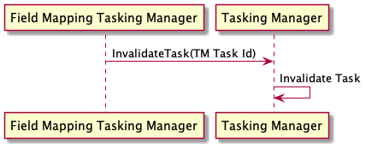
@enduml

